ASSIGNMENT 2

1.

At minsize =50

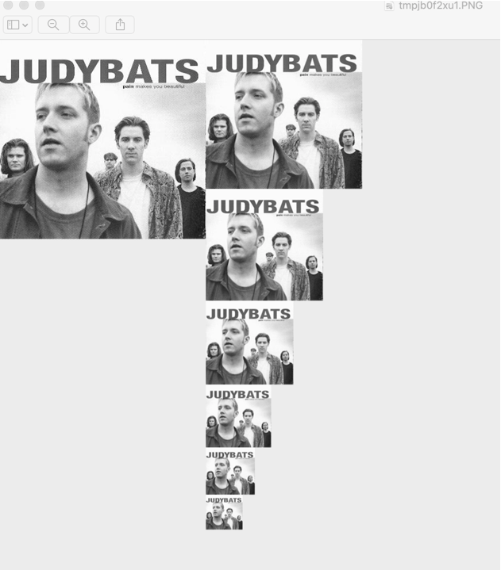

2.

Threshold of **0.52** leads to:

* + 8 false **positives** and
  + 8 false **negatives**.

3.

Images

* + Threshold = 0.52
  + Minsize = 50
  + Template width = 20

Fans = 3 faces

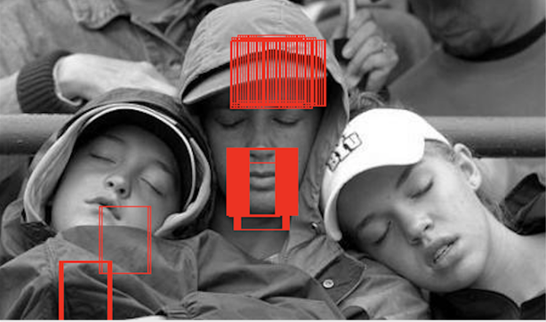

Family = 3 feces

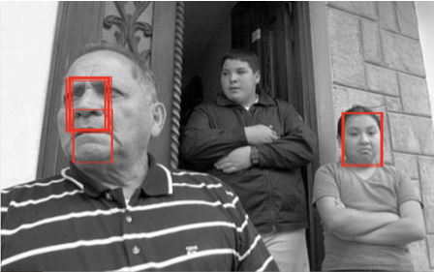

JudyBats= 5 faces

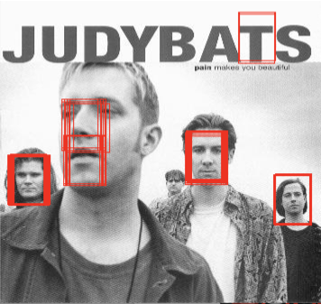

Students = 27 faces

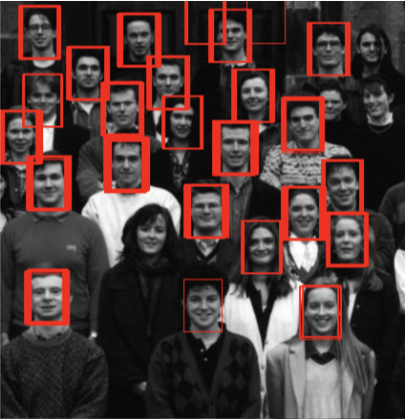

Trees = 0 faces

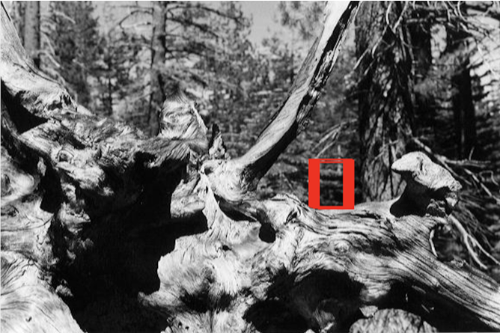

Sports = 1 face



4. Precision = tp/ (tp+fp) = 30 / (30 +8) = 79%

Recall = tp/ (tp+fn) = 30 / (30+8) = 79%

At a higher threshold, the ncc leads to a higher number of false negatives, thus increasing the recall rate in some image while providing a more precision in other images.

5. Tests for Q.5

threshold = 0.525  
  
minsize = 50  
  
# Fan IMAGE  
fan_image = Image.open("/Users/gautamsoni/Desktop/CPSC 425/hw2/faces/fans.jpg")  
pyramid = MakePyramid(fan_image, minsize)  
ShowPyramid(pyramid)  
template = Image.open("/Users/gautamsoni/Desktop/CPSC 425/hw2/faces/template.jpg")  
FindTemplate(pyramid, template, threshold)  
  
# Family Image  
fan_image = Image.open("/Users/gautamsoni/Desktop/CPSC 425/hw2/faces/family.jpg")  
pyramid = MakePyramid(fan_image, minsize)  
ShowPyramid(pyramid)  
template = Image.open("/Users/gautamsoni/Desktop/CPSC 425/hw2/faces/template.jpg")  
FindTemplate(pyramid, template, threshold)  
  
# JudyBats  
fan_image = Image.open("/Users/gautamsoni/Desktop/CPSC 425/hw2/faces/judybats.jpg")  
pyramid = MakePyramid(fan_image, minsize)  
ShowPyramid(pyramid)  
template = Image.open("/Users/gautamsoni/Desktop/CPSC 425/hw2/faces/template.jpg")  
FindTemplate(pyramid, template, threshold)  
  
# Students  
fan_image = Image.open("/Users/gautamsoni/Desktop/CPSC 425/hw2/faces/students.jpg")  
pyramid = MakePyramid(fan_image, minsize)  
ShowPyramid(pyramid)  
template = Image.open("/Users/gautamsoni/Desktop/CPSC 425/hw2/faces/template.jpg")  
FindTemplate(pyramid, template, threshold)  
  
# Tree  
fan_image = Image.open("/Users/gautamsoni/Desktop/CPSC 425/hw2/faces/tree.jpg")  
pyramid = MakePyramid(fan_image, minsize)  
ShowPyramid(pyramid)  
template = Image.open("/Users/gautamsoni/Desktop/CPSC 425/hw2/faces/template.jpg")  
FindTemplate(pyramid, template, threshold)  
  
# Sports  
fan_image = Image.open("/Users/gautamsoni/Desktop/CPSC 425/hw2/faces/sports.jpg")  
pyramid = MakePyramid(fan_image, minsize)  
ShowPyramid(pyramid)  
template = Image.open("/Users/gautamsoni/Desktop/CPSC 425/hw2/faces/template.jpg")  
FindTemplate(pyramid, template, threshold)